Happy St. Patrick’s Day!

As I write to you, I still have several inches of snow in my front yard!    In fact, it’s been 137 consecutive days of snow on the ground.  Oof!

I’m encouraged, however, by the longer days, the slightly warmer temperatures and the knowledge that Spring is truly around the corner.  Spring is synonymous with new life, and that’s what Maddie’s Place is offering to our fragile babies and their moms.  It’s been 127 days since we sent out our November 10, 2022, Newsletter (yes even the snow has been around longer!), when we announced our opening the month before and that we had already admitted 6 babies and 3 moms.

As of today, just 4 months later, we’ve admitted a total of 25 infants and provided room, board, and support for 14 of their moms.  We have been blessed to see the recovery of 25 precious little human beings.

In addition to the recovery of 25 babies, we’ve watched as many of their moms have made the commitment to seek treatment, to bond with their babies and to completely change the trajectory of their lives.   We’ve also assisted our moms with post-discharge housing and continued to stay in touch with all of them.   Our moms have become powerful ambassadors for Maddie’s Place and our Mission to provide nurturing care for drug dependent newborns and their mothers.    Recently, several of our moms asked to be included in a video to share their experiences at Maddie’s Place and the impact Maddie’s Place has had on their lives and the lives of their infants.

I encourage you to watch the following video.  Have some Kleenex nearby 😊    
<https://clipchamp.com/watch/6mIffwfn78f?utm_source=share&utm_medium=social&utm_campaign=watch>

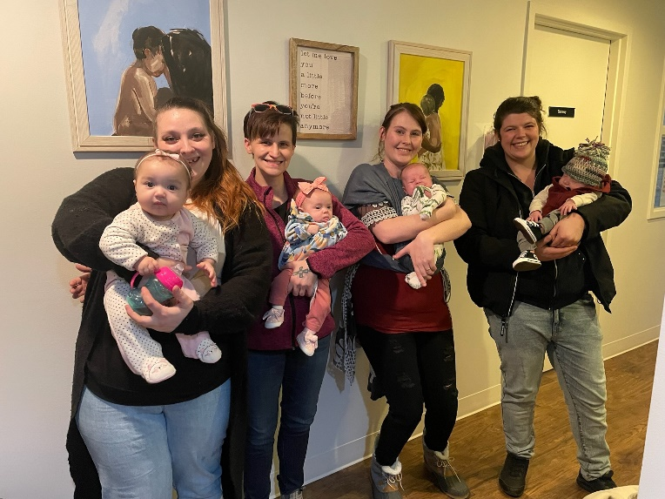

None of these stories would have been possible without the generosity of you, our supporters.  Collectively, you donated over $800,000 to Maddie’s Place in 2022 alone.   This outpouring of support enabled us to open our facility and to hire 40 paid staff.    **On behalf of our infants, moms, caregivers and the Board, Management Team, staff and volunteers at Maddie’s Place---THANK YOU!**

While your donations have been crucial to getting this plane off the ground, our long-term strategy has always been to have our services paid for under Medicaid.   However, this past month the Washington State Health Care Authority directed our sole payor, Coordinated Care of Washington, to stop paying Maddie’s Place under the billing code the experts had advised us to use.   How is it possible the State is actually fighting AGAINST us?  We’re not backing down!!

We had some cash in the bank, but not enough to sustain a payroll for 40 staff for more than a couple months.   Fortunately, Coordinated Care recently agreed to pay Maddie’s Place $500,000 over the next 6 months to keep us from going broke.

What about after that?  We have a plan!

Over the past couple years, we have been working with our State and Federal legislators to find a solution that would allow for Government payment of NAS services provided by pediatric transitional care facilities like Maddie’s Place.   On March 3, 2023, Rep. Marcus Riccelli (D. 3rd Legislative District) introduced legislation in the State House that would create and fund a 2-year Pilot Project on Maddie’s Place for $5.5 million, and a request for funding for WSU Health Sciences to research the prevalence of NAS in Washington State and Spokane County and the outcomes we're seeing at Maddie's Place to support our lobbying efforts.   Rep. Riccelli is a strong supporter of Maddie's Place.

Last Friday Rep. Cathy McMorris Rogers (R. 5th Congressional District) sent a letter to the head of the HCA in Washington State demanding an explanation as to why we are having such difficulties getting reimbursed for care.   Rep. McMorris Rogers is a strong supporter of Maddie’s Place.  We are encouraging her, as Chair of the Energy & Commerce Committee (with oversight over Medicaid and CMS) to make it far easier to obtain Medicaid funding for facilities like Maddie’s Place.   A solution there could open the way for hundreds of clinics like Maddie’s Place to sprout up all over the nation.

What needs to happen?   If our pilot project and research study are approved by the legislature, we’ll have full funding for our operations by this Fall.   We also have sought a Community Capital Grant of $250,000 to help us complete our remodel, which would increase our capacity from 8 infants and moms to 16 infants and moms.   In the meantime, our expenses right now are running about $145,000 each month.

How can you help Maddie’s Place at this time in our history?   By continuing to support us financially.   We would like to raise $250,000 between now and August 1.   Together with our payments from Coordinated Care, $250,000 will allow us to essentially “break even” while we push for approval of our pilot project on the state level and for a comprehensive solution at the federal level.

It’s fascinating to see a Democratic state legislator and a Republican federal Congresswoman work together to help Maddie’s Place.  Both Marcus and Cathy are passionate about helping us! That’s because they both realize there’s nothing political about babies born dependent on drugs.  This past Saturday, Rep. Riccelli held a town hall meeting in Spokane and said, “it’s no longer acceptable to just say this is a tragedy, we need to do something about it!”.  We agree!

Thanks for your incredibly generosity.   If you’re able to help us at this time, please send your check to Maddie’s Place at 1004 E. 8th Avenue, Spokane, WA 99202, or make your donation on-line at [www.maddiesplace.org](http://www.maddiesplace.org).

For the Babies and the Moms,



**Shaun Cross**

President

cell: 509.496.3753 | office: 509.315.5146

email: [shaun.cross@maddiesplace.org](mailto:shaun.cross@maddiesplace.org)

1004 E 8th Ave, Spokane, WA 99202